**TEAM NAME: RAD-DJ**

<https://github.com/DharalPatel/RAD-DJ>

# TEAM PROFILE

### Personal information

One paragraph per person, including name, student number, background, hobbies, IT interest and IT experience.This should also include your team’s chosen name.

**AHMAD AL SARI**

**S3682011**

* My background is Saudis where I was born
* I graduated from Eynesbury College in Adelaide. I’m studying IT at RMIT Uni in melbourne VIC.
* My hobbies are to watch TV (Netflix), Play playing Cards , Swimming ,travel.
* My interest is in Programming.
* I have been doing programming and studying about it for 4 years.

**DANNY PHAM -**

* <https://github.com/s3719046>
* <https://s3719046.github.io/Assignment1/>
* My Student ID is S3719046

My background is Vietnamese but i was born here in Australia. I graduated from Keysborough Secondary College, and is currently doing a course in Information Technology at RMIT. My hobbies are playing video games, playing badminton if i have the chance, watching TV shows like The Flash and Agents of Shield. I also like to take photos and building computers. Fortnite squad up. My IT Interest is in Networks and Cloud Computing.

My experiences in IT has been doing Computing in Year 11 and doing work experiences in Year 10 at a computer repair shop.

**RYAN Harris (**S3719229)

Website link: [**http://s3719229.s3-website-ap-southeast-2.amazonaws.com**](http://s3719229.s3-website-ap-southeast-2.amazonaws.com)

GitHub link: https://github.com/RyanHarris13

My background is that i’m half irish and half Australian, but i was born in Sydney, Australia, and have lived in melbourne for as long as i can remember.. I graduated from Brighton secondary college in 2017. I am currently in my first semester of studying IT at RMIT. I’d say that my hobbies would be playing video games (both PC and ps4) as well as watching tv, and by tv i mean netflix, stan and youtube. IT wise, i’d say i’m pretty interested in programming and creating programs using this, and i have had very little experience with IT in my junior years. Ideal job: Support analyst. meme

**JAIDYN JONG** (s3657960)

I was born and raised in Melbourne, Australia, with my background being half maltese and timorese. I completed my year 12 studies at Copperfield College, where I graduated in 2016. Currently, I am studying a bachelor’s degree in business, majoring in economics and finance and am in my second year of the course. In my downtime, I enjoy spending time playing sports and catching up with friends, working on cars, as well as playing video games and watching YouTube videos. In relation to IT, I am interested in programming, analysing databases, networking and cloud computing, where I have been taught the basics of these skills in my year 11 and 12 studies where I took IT related subjects.

**DHARAL PATEL|**s3719882

I was born in India then migrated to Australia at the age of 14 where I completed my VCE in Maribyrnong college 2017. Currently, I am studying Bachelor of Information Technology at RMIT. My hobbies include playing Cricket and video games and I spent most of my time watching Youtube and Netflix. My career ambition is to become the very best programmer thus I code and program in my spare time. This passion of mine started back in high school when I was taught basic coding in my IT classes.

Link to website: <https://s3-ap-southeast-2.amazonaws.com/s3719882/index.html>

Github link: https://github.com/DharalPatel

### Team Profile

**Dharal:**

**Myer Briggs:**

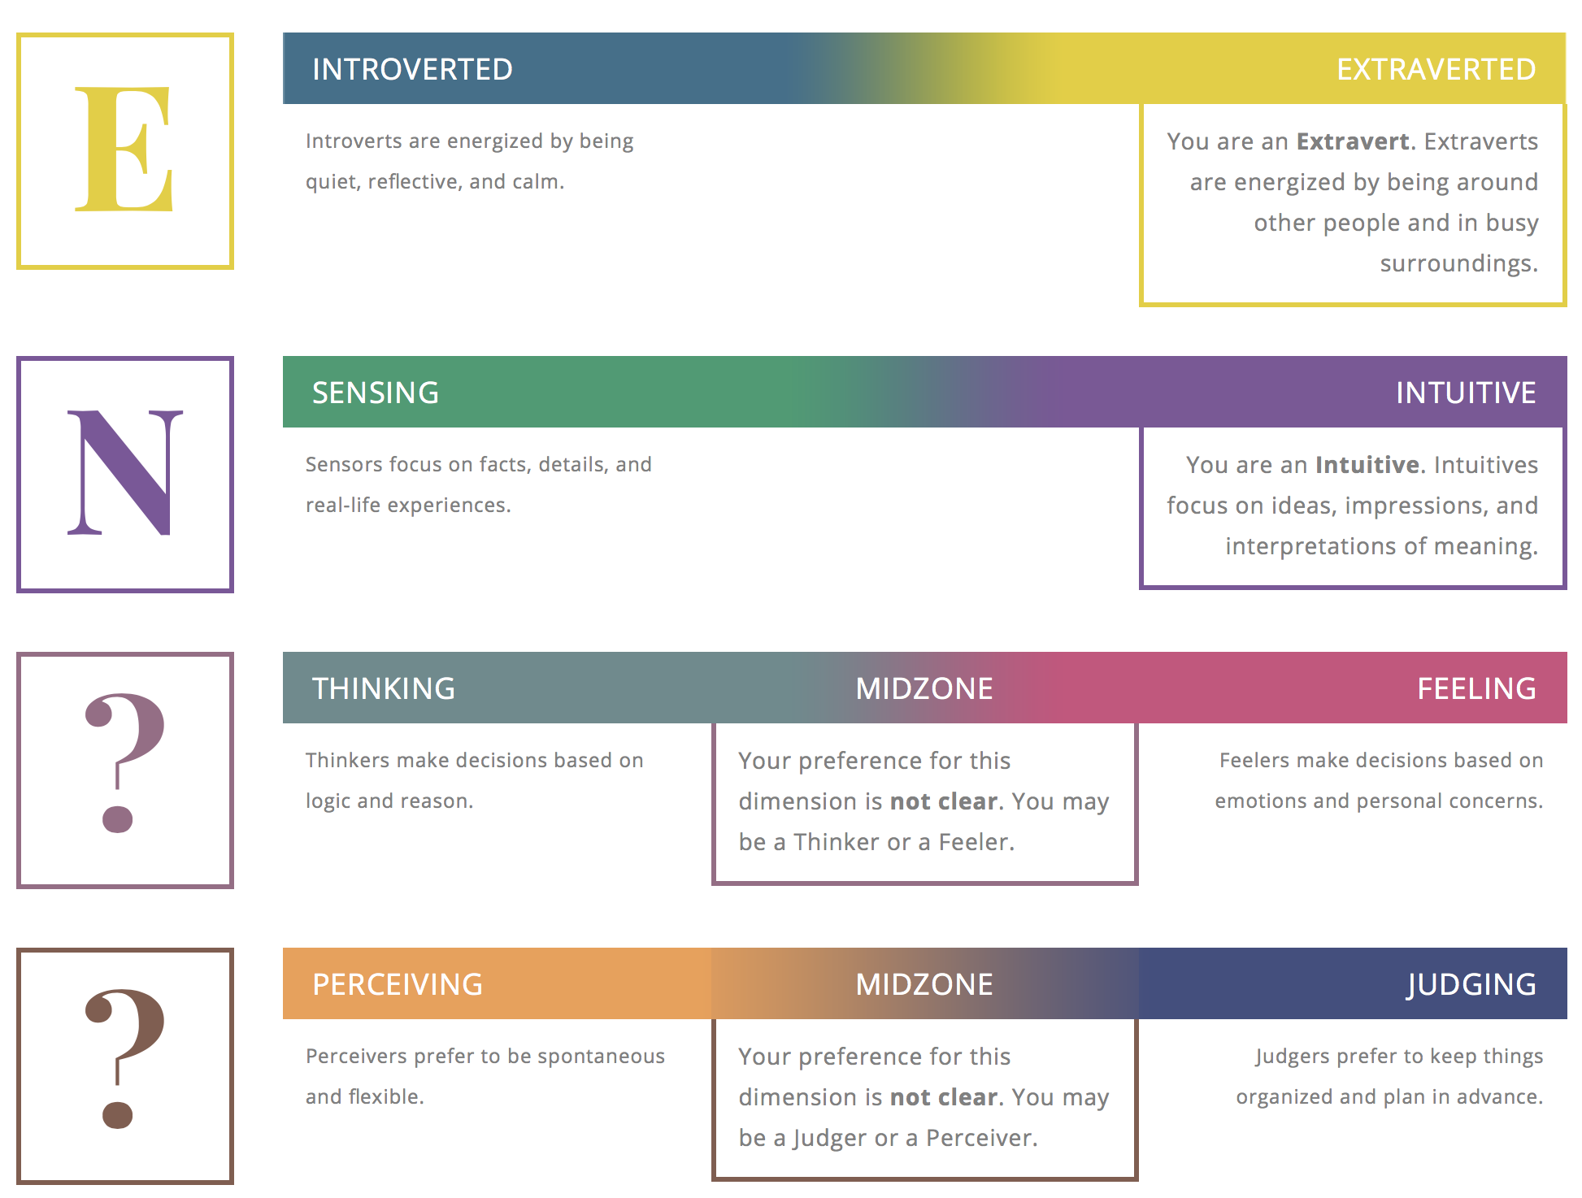

**Learning Style:**

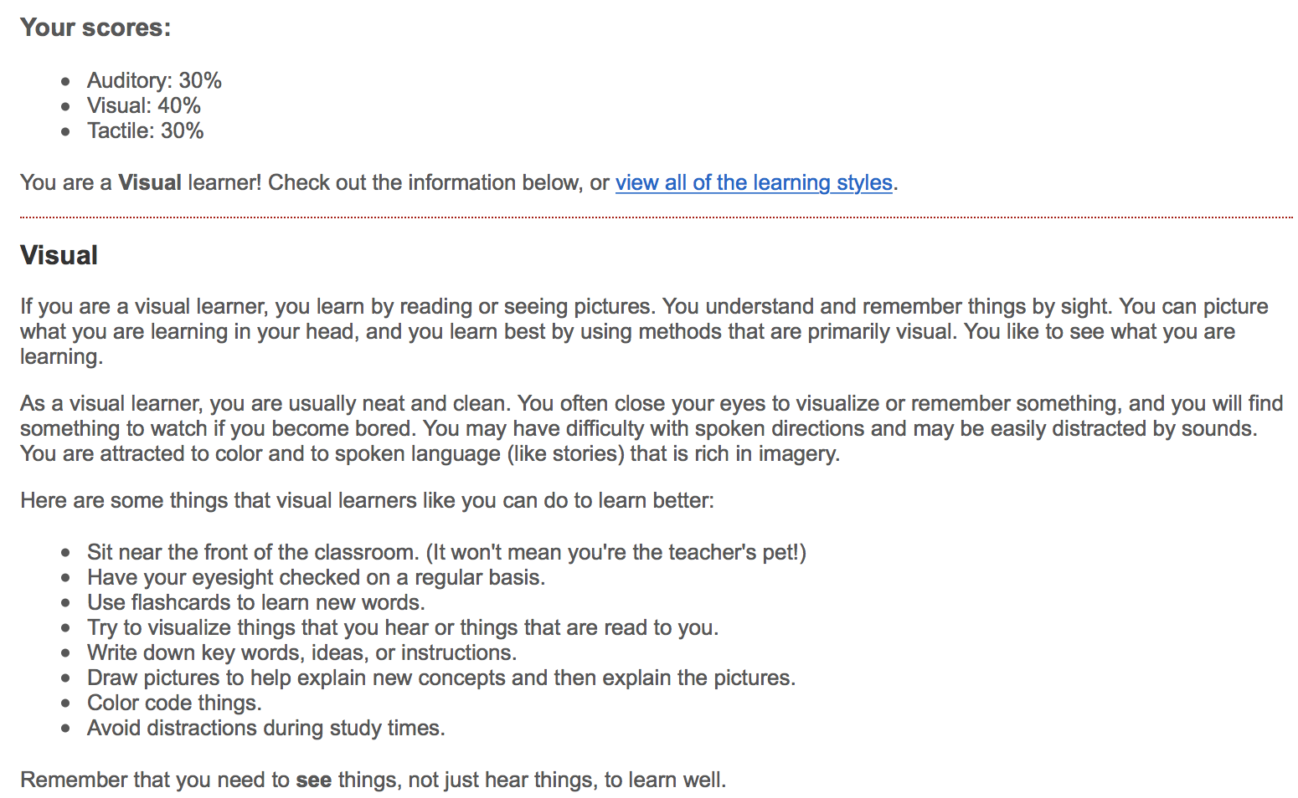

**Creativity Test**

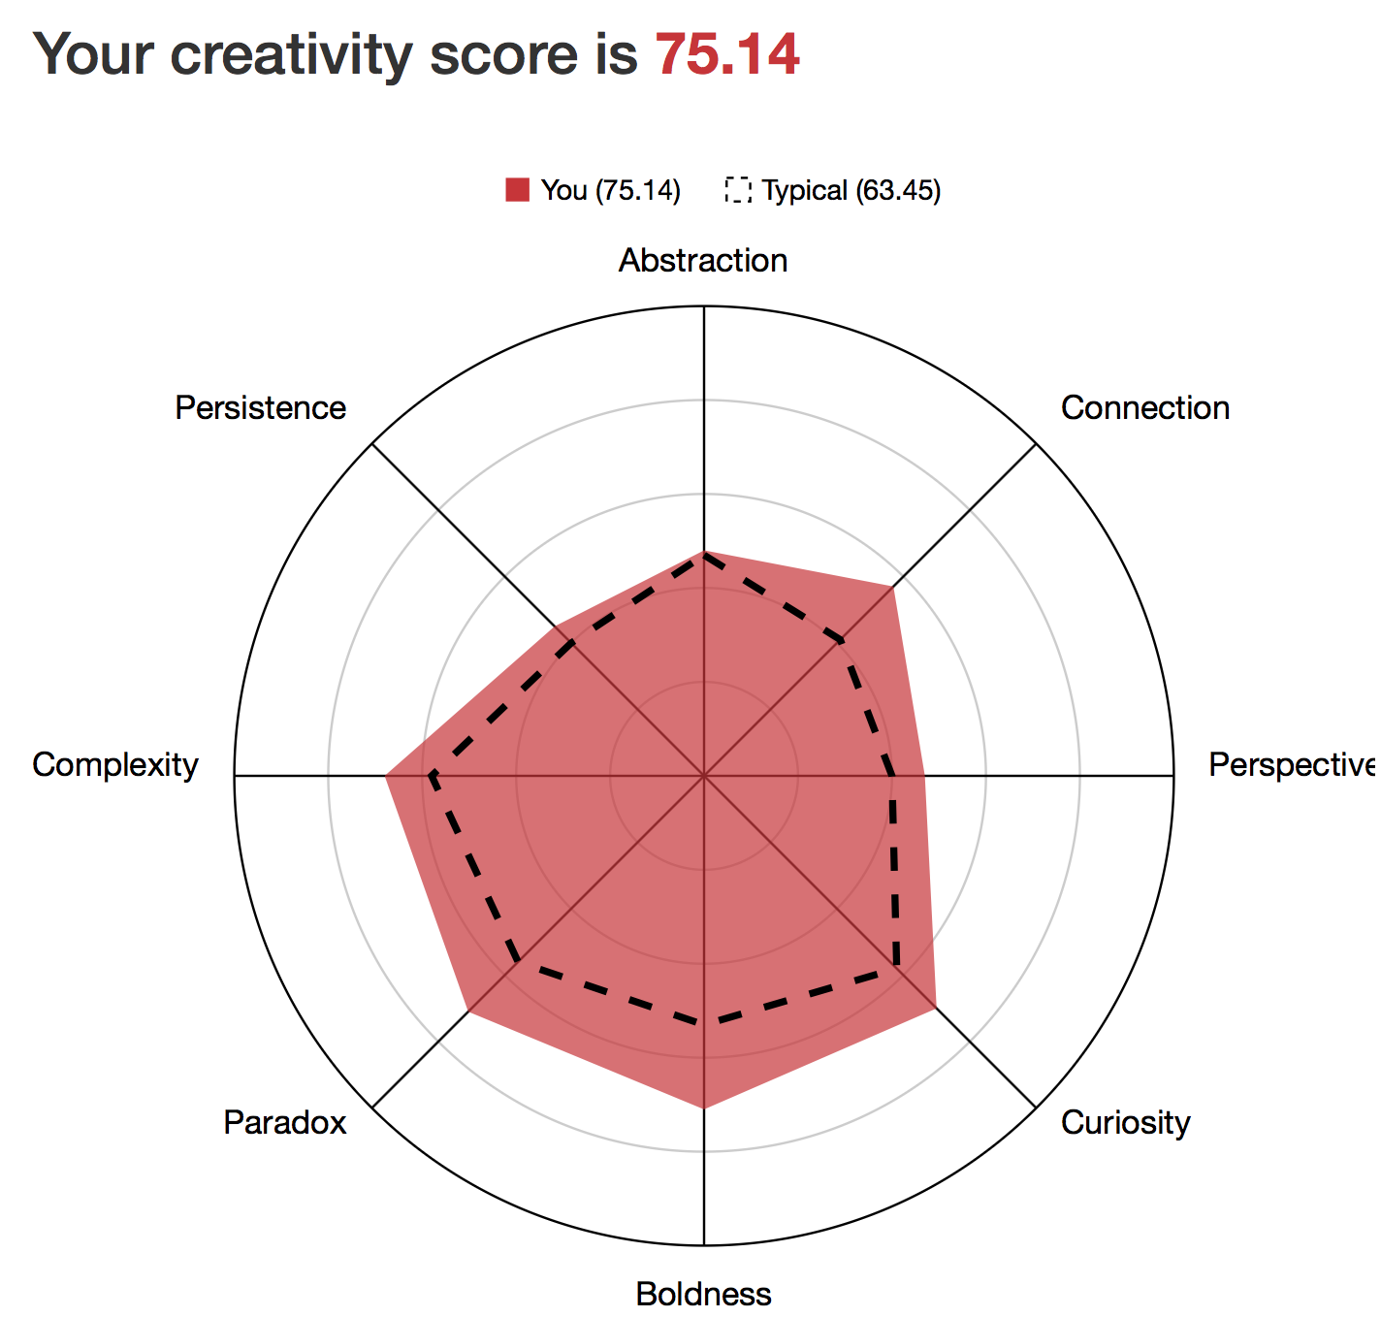

This information will be helpful to the group as it shows what is my personality, my learning style and my creativity. This information is necessary as all group members should know what can I do, how can I do and in what ways I can do. Through this all group members can know that what tasks I am capable of doing and how good I can do them and how creative I can be in completing tasks.

### **Ryan:**

**Myers Briggs test:**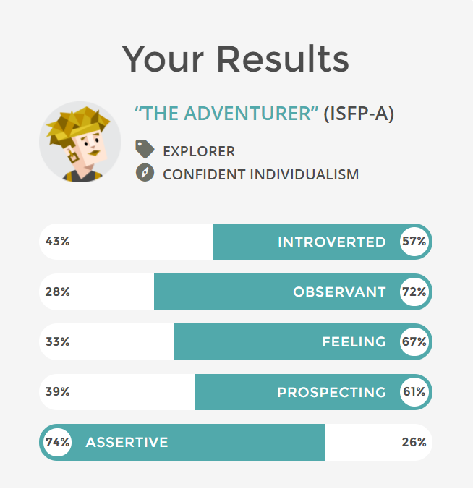

**Learning style test: primarily a visual learner**

* **Auditory: 10%**
* **Visual: 55%**
* **Tactile: 35%**

**Big five personality test:**

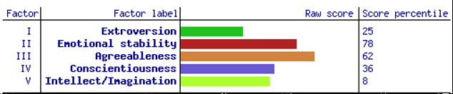

This information will be valuable as it shows how best i learn, as well as an abundant amount of information about my personality, allowing them to best understand me as well as how to interact with me. These tests can also dictate how the work is done, as i prefer written and visual work.

**Danny**

**Myer Briggs:**

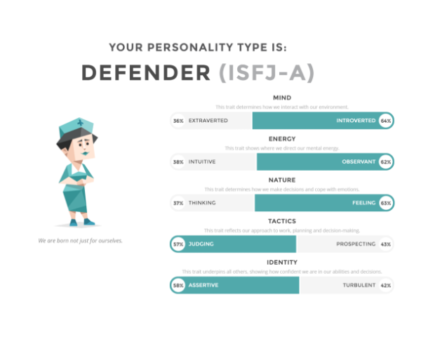

**Learning Style:**

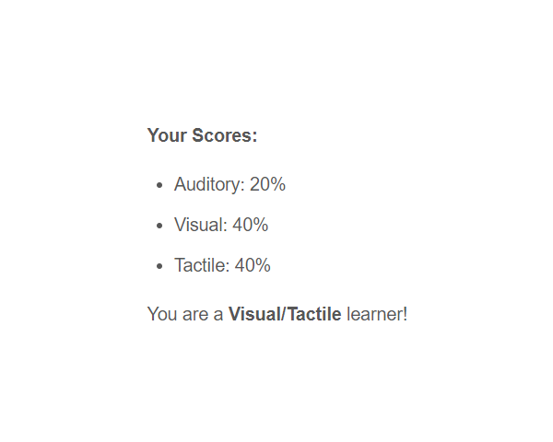

**Career test:**

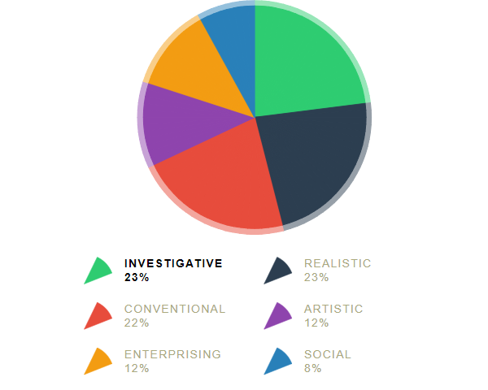

The results depict how i best learn and the interact with my team. It portrays both strengths and weaknesses. I am more of a tactile and visual learner rather than a auditory learner. This is necessary for my team, as it shows how i understand information.

### **Jaidyn:**

**Myers Briggs Test:**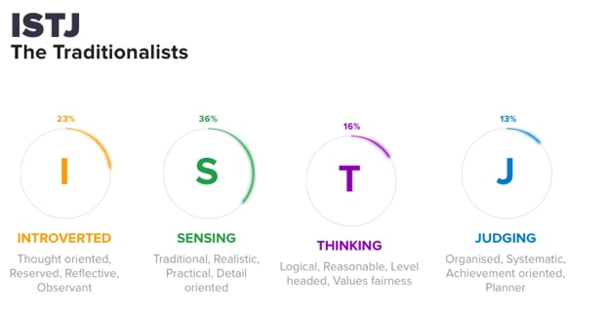

**Learning Style Test:**

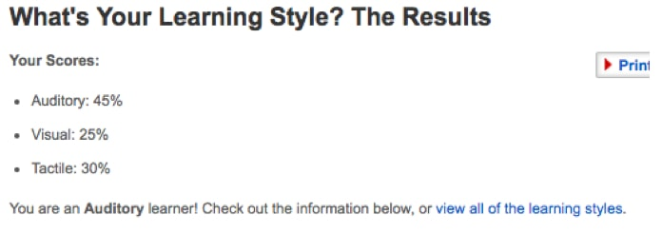

**Big Five Personality Test:**

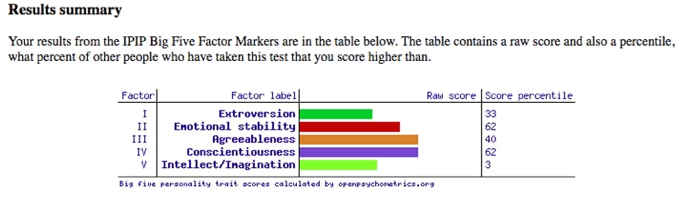

These test results will be useful to my team because it displays my personality type, where my group members will be able to know what I am and am not so capable of doing in the project. The results also show how I am able to comprehend and understand information presented to me, which may also help my group members and myself in understanding new information. I am therefore able to play a role within my team where I am best suited based on my test results, such as being the team’s information organiser.

# Tools:

We have set-up the website on GitHub. The link will be provided here: <https://dharalpatel.github.io/RAD-DJ/>

# Industry Data

Interview a Proffesional:

Interviewer: Ryan Harris

Interviewee: John Harris. managing director of AAPAC and financial services lead

### Me: OK So could you please tell us about your I.T. work, what exactly do you do you do?

John: what do I do?

me: yeah

me: What's the title of your job

 John: oh, I've got a few jobs let me talk about..

Me: do you have a main one?

John: Yes so laid out a technology consulting practice for Accenture financial services in Australia New Zealand as well as in AAPAC so asia pacific, africa through to Japan with everything in between.

Me: So what does that job entail?

John: That job. Does a few. things so we have a number of consultants who are doing the consulting for the clients and so it's technology consulting so that’s doing things like business cases or planning or Architectures creation of architectures, the definition of architectures in a project context so it's kind of like twelve weeks/ six weeks of a project to talk to everyone from; the client to you know kind of discover what their needs are and then create plans for them and get them to buy into those plans and deliver them. so that’s kind of the work we do. And so then my role is to make sure we have all of the capabilities to do that, so the right people with the right knowledge and the right capabilities.

Me: so You hire people

John: yeah, yeah hire people

Me: make sure you've got the technology you need, and the people you need

John: yeah, the experience they have and need, so for example at the moment we've been investing in blockchain and artificial intelligence folks, people who have had a practical experience of that.

John: But they have to be kind of consultants as well so, so being good at the technology is one thing, but being good with people and drawing out of them what they need to do what they don't need to do so it's kind of a different skill than the usual, you know, project doing skill.

John: And so the job then is actually across the patch do we have those skills in the right volumes, which ones we can invest in and to what extent. for example we can over invest in some skills as well, I mean there's some skills we just don’t need because we just don't, don't need to have the detail in

Me: so do you try and find the right people for the project for your clients

John: Yes, so we have our folks and then, both in terms of trying to sell to the clients in terms of demonstrating the we're better than the competition.

John: And so then Matching our people with the needs of that particular client. There's a bit of personality matching, and Capability matching in terms of their skills matching as well. And In some circumstances also matching in terms of industry knowledge. So do they understand; banking, for example. You don't send someone who understands insurance to a banking client. They don't get on. So it's a bunch of matching their. So there's math as well associated with the job. We've got targets where we need to make margins, we need to meet we also need to make revenue, the margin is a certain percentage of the revenue and we need to grow everyone needs to growth. Sometimes you need to prune, sometimes we need to remove folks.

### Me: So what industry do you work in?

John: Financial services. So financial services is pretty complex and broad right, so we divide it up into insurance, capital markets and banking. Here in Australia banking is stronger than most. It's inverse in japan. so japans capital markets is stronger than anything else, insurance to some extent as well. banking less so for us.

But that's the space that I work in.

Me: so what is your company, what do they focus on

John: Accenture?

Me: yeah.

John: Everything. We divide the world up into five main industries:

* products so like you know Coles and Woolies or something
* Then resources so B.H.P. and the gas producers and things like that Woodside would be a client of ours is a client of ours in resources
* CMT, which is a bit of a mixed bag, so: communications And hi-tech. So on Bowing for example is a client of ours over in the US as are some of the rocket manufacturers and things, so that's hi-tech. uhh you know Google's a client of ours, Facebook is another one in the US. You know in the US enormous role so that there isn't a common problem and we're seeing how by G.P.S. Our government health and. Your state support for this government actually right

Me: so what do you supply for everyone?

John: A broad range of services so, from strategy through outsourcing, but is still mostly a services based company. Although we dabble in some other stuff and

Me: it's mostly IT services?

John: mostly IT services yeah. so we don't do any legal services, we banned ourselves from that. You know we don't do business with bit coin operators for example, so there's some stuff we don't do. But you know if you want a strategy done for your company in terms of where you should go to. you want marketing done for you so brand recognition planning we do that work. All the way to building systems and solving your business problems (management consulting). Implementation of large technology projects, outsourcing so, both in terms of business processes, so you need business processes to run so procurement for example is a common one in financial services that we run. And outsourcing as in you know running and running a technology stack for you, as a client, or with you it depends on the model. so as to why we work with our customers

### Me: so aside from your main job what other that types of work to have to do

John: what do you mean types of work?

Me: like what kinds of work do you do, like do you just talk to people or do you have to manage a lot of systems

John: Ah, right. mostly I talk to people. I have a stack of systems that give me data so I can pretty much, with my fingertips look at our financials in kind of all different ways you know so we have some pretty good systems there. There's a whole bunch of other systems we have with HR, scheduling and the actual gathering of the financial information. we're pretty good with finance really because we close our books about five days after the end of quarter. Not a lot of companies close that quickly, globally so we do that globally. So there is a bunch of me interacting with systems, I don't do much on them. And then a lot of meetings with folks, I talk to a lot of folks. Less so with clients and customers than I have been in your two years but it has been totally internally focused for me in the last two to three years. And that could be conversations with people, People who kind of report to me in some respects in a different geography for example i had a conversation with Wendy who runs AZN for technology consulting and that was on a voice call for an hour on Friday and then later in the afternoon it was with the AAPAC leadership team on the promotion candidacy for our managers, senior managers and MD's if you like. so commenting on whether these folks are ready for the process. And that was on a video- conference, (teleconference) and then one in the office like lots of kind of face to face meetings of the folks. So above, down up if you know what I mean and sideways as well so to talk to higher ups lower downs. So my peers in different industry groups, as well as my peers in supply organizations to me. So my suppliers inside the firm. It's a complicated web.

### 

### Me: ok, who Are all the different people you interact with in your work, please tell me about them

John: I got onto that just a little while ago but… Some of the time I directly report to people in my group.

Some of it's, because we are a very matrixed organizations, not as hierarchal as some. So if you go to a bank it's very hierarchal yeah so it's easy to determine you know who exactly my boss is and who their boss is and stuff. It's way harder to determine who exactly my boss is in Accenture. Because we're actually a global company which is truly distributed globally, no headquarters anywhere right so, so it's then a matrix of organization so like I said before I mean, there are clear clearly people who can give me orders if they like above me so call them bosses. There's peers of mine so you know I'm in an industry group I own the P&L the other guys have got copies of the P&L, also they run their own organization people that they need to take care of who also report to them. I talk to them about things, say for example another call I had on Friday I was with the guy who runs digital. Digital delivery, in terms of all the jobs that we're doing together. And you know, are we working together effectively are there any actions we need to take to make them work better. So that's kind of a peer to peer discussion you know we both got the hierarchy underneath. And then sometimes it's down with people in our group like sometimes, if you know you're doing well, here's a career counseling discussion, good bad you know. And then with the mechanics of what runs our practice so the HR, our finance guys was. Legal sometimes you know I talked a legal guy on Friday about some something going on with one of our clients.

John: yeah, so it's lot of lot of interactions that way. I mean a lot on e-mail or too much on email, I must get like three hundred or four hundred e-mails a day so.

### Me: So please tell us about your interactions with other IT professionals.

John: Competitors and such?

me: uhh, people you work with and such.

John: it probably fits into a few different camps.

Me: You would have clients peers and competitors?

John: Yeah so: clients So there's a range of people inside the clients teams we speak to all the time in different clients and it's an industry so a lot of people talk and that's part of, that's part of the industry. They say that Melbourne and Sydney are still kind of small cities when it comes to the industry, and they are, so you know it's about relationships and you know you talk to them about things that, you know, not gossip but You know, just the information and facts and the realities. *we work in an industry where we're all very interested in getting it right*. We're, none of us are interested in getting it wrong. Even our competitor. I'm not interested in our competitor getting it wrong. I want them to get it right, because when they get it wrong it's bad for all of us. So we do help our competitors it's just not too much because they're still our competitors. And we do talk to people, so you know for example this week I had several conversations with client guys you know just chit-chatting and talking about what's going on in different places

Me: would that be in the IT world? Or just like in general

John: actually Well, yeah, sometimes in general so one bloke I was talking to was a guy in Sydney who he's on the business side. And then someone from one of our clients he's a program director for the work that we do. I spoke to them this week, is probably the only client interactions I've had this week. Then you talk to, WE talk to software vendors quite a bit, or you know all vendors of other services. sometimes they're competitors, sometimes they're not, sometimes it's hard to figure out. But I'm generally talking to them sometimes we work for them but most of the time they work for us it's kind of the position we're in in the ecosystem. so I had a few conversations them, and they funny, they're like water cooler conversations. I mean here you bump into someone you have a chat about something, they exchange information, they ask you, you know about what you're doing and you ask them what they're doing and there can be some common level of discussion. And I talk to our competitors too it when, I mean you know we talk to people from a range of very different competitors, you know sometimes we do play together on things so you know it's the world's a nice place and you've gotta be nice to other people here so, it's interesting to talk to

Me: you can't have It be all cat and dog

John: nah, you can't you can't

### Me: ok, so What about your interaction with clients or investors, have you ever talk to investors?

John: Not investors no, this is an interesting question. we're a pretty large company so our investor base is very broad.

Me: So you're not able to meet a lot of them.

John: no

Me: what about clients then?

John: Yeah clients all the time

Me: is it mostly about what you're working on or is it sometimes just general

John: a lot of the time it's just general chit chat. You try to pitch them things or at least just have a conversation. Sometimes a client's calling up saying " hey you're not doing this right you need to get better at that" you know it's a good bit of going on. And that can be you know a range of things from just an informal chat and that "hey, you have better know that that X Is going to happen if you don't do Y.." all the way to formal you know, kind of letters on contracts that say that we're going to terminate you because you're hopeless. To you know " wouldn't it be great if you could come to us with a proposition that looks like this because I've got a big problem I think you can solve that for me" which tend to be more the conversation we want to have. you know that those kind of conversations happen all the time in many different forms so from coffee all the way through to you know formal board presentations and meetings and such right now

me: is it mostly OK talking with clients?

john: Yeah mostly, So you get like most work environments you have people who are hell bent on making everyone's life a misery and there's others who are just completely normal right just easy to talk to know what they want and they are balanced they're not they're not a goose they're not unintelligent they are intelligent they get the world's a complex place and that things go right and things go wrong. And you know that mostly we're here to actually get along and move forward. We do get a lot of gooses around the place who just I don’t know, they're either just not intelligent or they're just to hell bent on making the world a horrible place.

### Me: What aspects of your work do you spend the most time on.

John: Probably. Today it's probably on solutions for clients, so what's the deal look like and do we think that deal's a good idea and how much risk are we taking in that deal or not. I guess because I've been in the industry for quite a while I've seen quite a number of deals and going good and go bad. So you do sort of a sense that others don't have because they can't integrate because they don't have enough data right, I've got a lot of data so I can generally get to a solution pretty quick. But that isn't saying that I don't make mistakes. Most of my time is on the deals you know what does the deal look like, why do I think that's good, do I think I'm about to get my margin, if I think that's good value for my client. (because you've got to think about you know think about in terms of value to them rather than just ripping them off right, because you don't last long if you're ripping folks off And you're not providing what you believe to be value) Now that's an interesting question too, because you may not know what value is, you've gotta be really quite self-aware when it comes to this stuff. so if you can nail out a deal and you think you can make fair money out of it, then all good, go for it. and that's what I spend most of my time one

### 

### Me: Which aspects of your work you find the most challenging

John: uh, probably sales, yeah, or understanding where the client is coming from, or getting them to understand something, because often what you get is difference of opinion or a difference in paradigm so they have a very different world view than than the one we would have right or we don't completely understand it and so in that environment you can be pitching something or talking to them about doing something and they're just not getting it. The client in general case they got the money they got the need So we would have the resources to fulfill that need and kinda without that meeting of the minds it's actually kind of difficult to move forward. Because in our industry it's a very complicated industry, I mean machines Live on a knife edge most of the time, if they fall over they break and they don't lie they don't have a bad day they just do what they do, so you've got to get it right and getting it right takes a lot of effort and so if you don't think there's a lot of effort needed to get it right that's a different conversation and most of our clients are in the space of you know why does it cost so much or why can't it be done earlier so we do the job right once. I say to the guys you know, measure five times cut once, not cut five times and waste a bunch of timber.

### Me: OK Finally, can you share example an of the work you do the best captures the essence of the IT industry.

john: the work we do, as in the work company does?

me: You specifically.

John: A few years ago I did a very large program for a client here in Australia and it was a large thing that we did, and for them and still it is in existence and it's still in production. And it's strategically positioned them very differently for themselves right, so that they were able to sell their product and combine their product in a very different way than they had before us. You know internally there was that debate as to whether it's actually valuable or not but I think it's very false debate because they just have forgotten what it was like before that system came along and how fractured their business was before we came along. And then so it did actually provide a second benefit for them but also a second benefit for their customers and, However putting it together wasn't easy but it was a lot of hard work and a lot of, we're talking millions and millions of customers billions of rows of data

Me: was it like an I.T. System

John: yeah , it was a huge IT system, across an enterprise wide right so across you know half their business it impacted and changed. this is a company that has got forty thousand employees here, so and every one of us in Australia is a consumer of these services at this company so you know it's fundamental material to running them and kind of running the country and you know we, you know thousands of us went through and did this program for three years to implement it. And you know that that's not the only program I think that my company has done but that's where we live in the ecosystem in the kind of the material things. And I guess sometimes it's a step change but not a big step change so how big of a step change is it and I think that that's interesting we've done these you know fundamentally large transformation programs and we've got the mechanics and discipline to get that done, because they're kind of tough to do and you've got to have a lot of discipline, how do you get a good thousand people to do the same thing? Do you just tell one person to tell the next person and so forth. You've got to have structure, issues of risks for example need to be in the database and only to be codify and practiced and put to someone and then measured as to whether that's been done or not right. that's just issues and risks, there's a whole stack of other stuff just needs to be mechanically managed and driven, it doesn't happen by accident. so that's the world that we exist in today but then technology is moving us to a different world and yeah, it moves faster and it's done in a more agile fashion all the rest of it. But the fundamental shifts and change in our society are actually going to get bigger and the IT community is actually the one who's driving that and increasingly actually in a smaller number of hands there's not as many people in IT as there historically was, we aren't producing that many graduates right. So yeah it's an interesting place to be I think as an industry you know.

Me: That's all the questions. thanks for talking with me